Operating Systems–1: CS3510
Autumn 2018

Programming Assignment 1 : Multi-Process Computation of Execution Time

Instructor : Dr. Sathya Peri
Author : Puneet Mangla (CS17BTECH11029)

- Design of Program :

As soon as the child process is created , it creates a shared memory object. The size of the shared memory object is fixed and is equal to sizeof ( struct timeval ) beause we only need to store before execution timestamp. After creating the shared memory the child process stores the before execution timestamp in shared memory for the parent process to access in future. Then it starts executing the command.

After child process terminates , parent process immediately records the timestamp and stores in other struct timeval instance . Then it extracts the before execution time from shared memory via mmap and calculates the elapsed time in seconds.

The visual design implementation is given below :

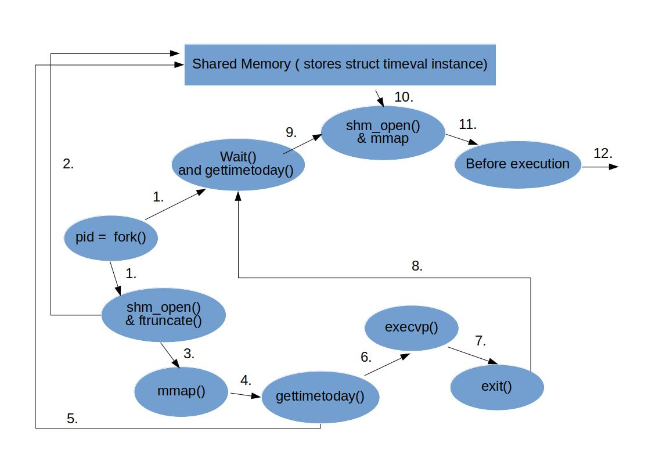

1. Creation of child process and parent starts waiting after waiting its records timestamp
2. Child process creates shared memory instance.
3. Then it maps to shared memory which returns a pointer to shared memory instance of type struct timeval* .
4 and 5. Child process stores before execution timestamp using pointer it received .
6 and 7. Child process executes command and exits.
8. parent process starts execution and calculates current timestamp.
9 , 10 and 11. parent links with shared memory and gets before execution time.
12. Calculates the time elapsed.

2. Source Code Highlights :

- char* command[argc] – stores the command to be executed by child process.
- ftruncate(shm_fd,sizeof(struct timeval)) – allocates sizeof(struct timeval) amount of memory to shared memory instance.
- double etime = (double)sec + (usec/1000000.0) – calculates the elapsed time from seconds elapsed and microseconds elapsed.
- struct timeval* before_execution – pointer to the shared memory instance further used in gettimetoday().
- gettimeofday(before_execution,NULL) – stores the timestamp where the pointer points i.e to shared memory instance.

Functions Used :

- fork() - forking a child process
- shm_open() - creating a shared memeory instance
- ftruncate() - allocating memory to SHM.
- mmap() - link the process with shared memory
- gettimetoday() - getting current timestamp.
- execvp() - execute a command line command.
- wait() - wait till child process ends
- shm_unlink() - destroy the shared memory created.

3. Output Analysis:

Since the elapsed time of command fluctuates every time , we took the average reading over 5 executions of elapsed time for output analysis.

- Average time for actual program without parameters

Executing a.out a.out a.out ...10 times ls , we obtained 10 elapsed time which when plotted gives a linear graph.
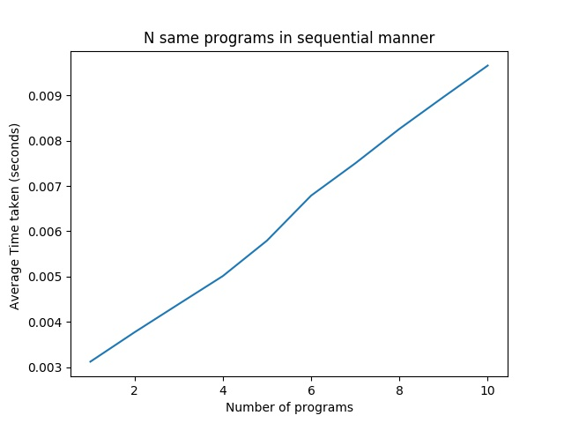

Note :
need to remove shm_unlink to avoid segmentation
fault.

From the Slope of this graph we can calculate the execution time of parent process after it stops waiting for child. The execution time comes out to be 0.000713 seconds . This value is hypothetical as executing ./a.out wthout any arguments still creates a child process ( which does nothing ).

- Average Execution time for standard linux commands.

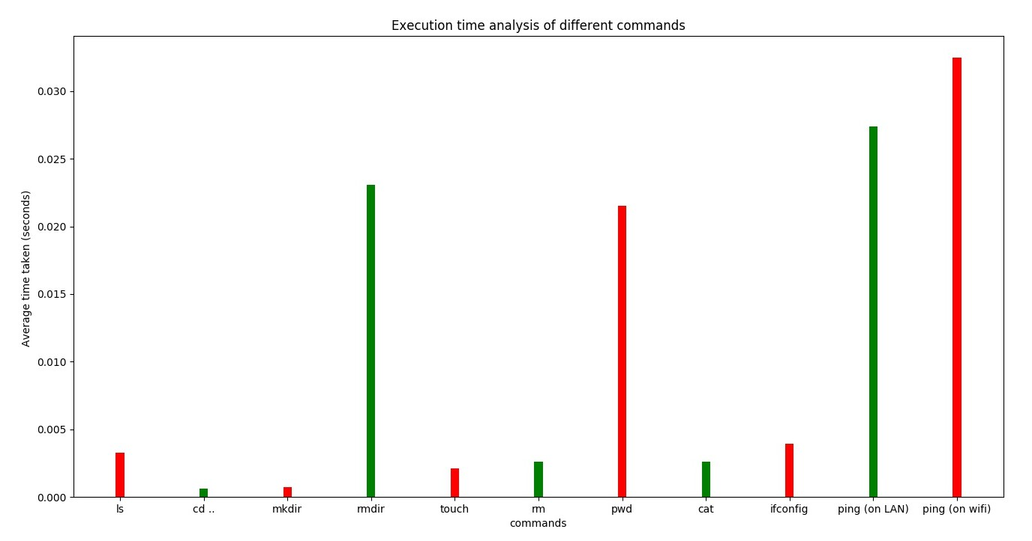
ping command depends on internet speed , the time taken by it on wifi is larger than that of LAN.

- Average Execution time of ‘ ls ’ command with different flags.

From the graph we can see that flags like lh,ltr,author takes more time as compared to other flags. The reason is because the amount of information given by these flags more . For example flag lh gives rwx permissions , date of creation , size , author etc. Which requires more execution.
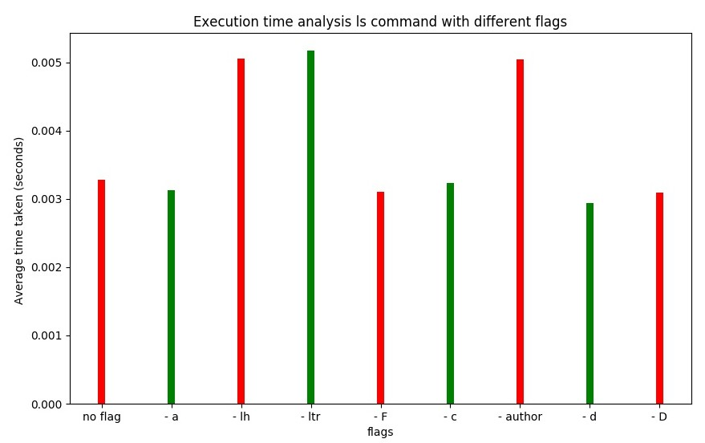

- Analysis of ‘ tar ’ command on files of different sizes.
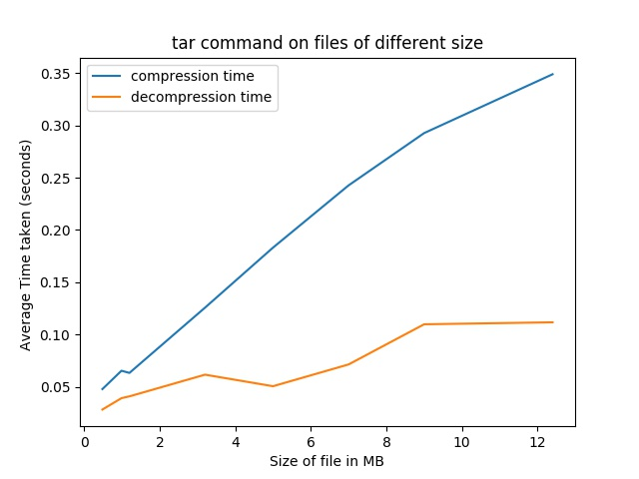

Taking 8 books of different sizes and by using tar command , noted the compression and decompression time. From the graph its clear that compression time increases almost in l inear fashion as the size of file increases. The time for decompression is much smaller than time of compression.

- tar -czvf , bzip2, gzip time comparison

Compression time for various compression commands is given below.
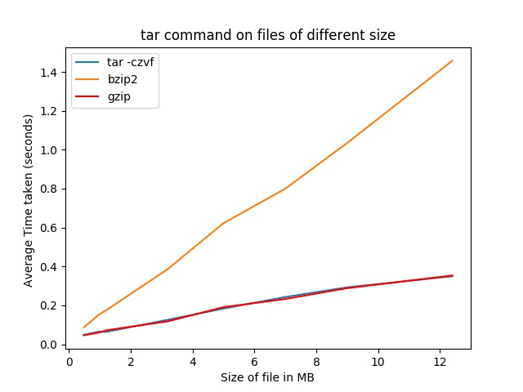
The compression time of all the three commands follow a linear fashion with size of file . The interesting point is tar -czvf and gzip takes same amount of time to compress files which is much smaller than that of bzip2 . So its good to use gzip and tar for file compression.

Gzip is based in finding repeated strings in the file and replace them by pointers to their previous appearance. It's in the family of the LZ compression algorithms. These are usually very fast.
Bzip2 uses Block-Sorting where you need to do a suffix-sort of each block.

